**Pipeline Deployment using ECS FargAtE with Terraform…..**

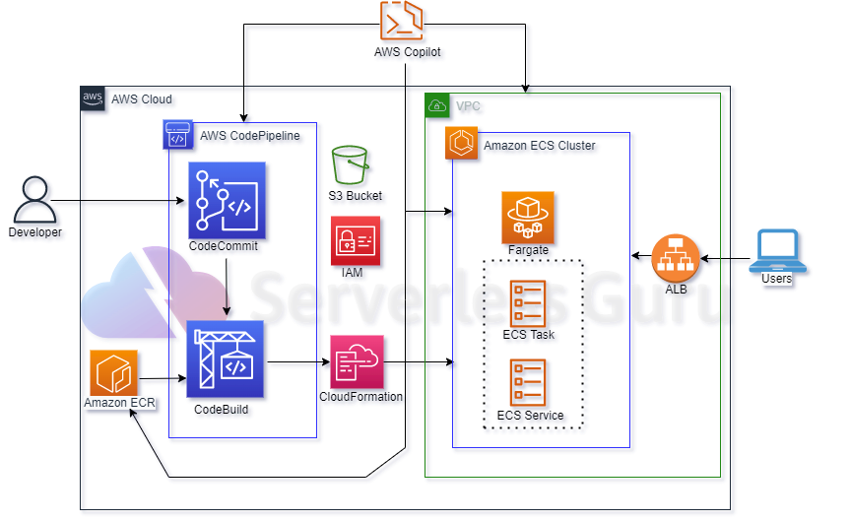

* Deploy 2 services in one cluster with single load balancer.
* **Terraform:**
* ECS.tf - - ECS CLUSTER, 2 TASK DEFINITION , 2 ECS SERVICE
* CODEBUILD.tf – compiles the source code , run test and produce the artifact that ready to deploy.
* DATA.tf – Existing service that are available in aws, so we can use
* IAM.tf – create role and policy to execute the task.
* ALB.tf – Setup Target group, listener and listener rule.
* PIPELINE.tf – continue delivery the service to automate the steps required to release your software.
* S3.tf – Store the artifact in the bucket.
* Security group.tf – configure the port for the application
* Variable.tf – allow to write configuration that is flexible and easier to reuse.
* VPC.tf – provides a logically isolated area of the AWS cloud where you can launch AWS resources in a virtual network that you define.